QuickLink Tutorial
by Taylor Lafrinere

1 Introduction

The purpose of this tool is to give complete control of the input-link to the Soar programmer. QuickLink can be thought of as a way to “fake” an external application, such as a game or simulation, in order to test specific circumstances that are rare and/or hard to reproduce. QuickLink currently can only be operated through the use of a command line interface.

2 Getting Started
2.1 Launching
The QuickLink executable should be located in <soar-dir>/SoarLibrary/bin/ and is appropriately named “QuickLink.” Once you find the icon, double-click it to launch the program. The QuickLink (QL) command-line window will pop-up. On launch, QL will internally create its own instance of Soar along with an agent named “QuickLink.”

Here are some of the basics about the QL command-line:

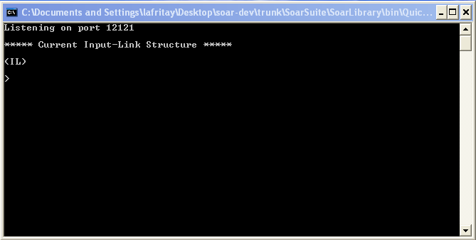
This is the port that Soar is running on. The default for Soar is 12121.
This is where the current input-link structure will be displayed.

QL has a built-in command that allows you to spawn the SoarJavaDebugger and have it automatically attach to the QuickLink agent. To do this type:

debug
Spawns the SoarJavaDebugger and establishes a remote connection to QL.

The QL command-line should indicate that a new connection has been made. If for some reason the “loading…” text doesn’t stop printing periods, there is most likely something wrong with the path information on you computer. First, make sure there are no other instances of the SoarJavaDebugger open on you system. Next, verify that both the QuickLink executable and SoarJavaDebugger jar file are both located in <soar-dir>SoarSuite/SoarLibrary/bin. If things still don’t work, make sure that your LD_LIBRARY_PATH and LD_RUN_PATH environment variables are both set correctly. Note: QL does not need to be attached to the debugger in order to run, it just makes it easier to see what is going on.

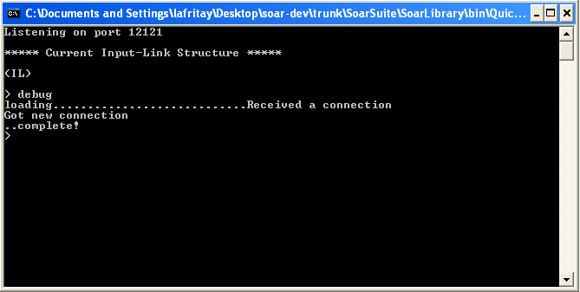
Verifies that a connection to the debugger has been made.

QL is now ready to start simulating an external environment. At any time we could start adding WME’s to the input-link and running Soar, but that wouldn’t be any fun because there are no productions loaded. So in order to make this interesting, lets load a TankSoar agent’s productions. This can be done either via the QL command-line or through the SoarJavaDebugger (Note: All Soar command-line commands can be run through the QL command-line interface. Any command that QL doesn’t recognize will be sent to the Soar command-line. This will come in useful later when we talk about scripting in QL).

In the instance of the SoarJavaDebugger that is connected to QL, click File | Load Source File …. A window will pop up to the location that you last loaded Soar productions from. Navigate to the SoarSuite/Environments/JavaTankSoar/agents/ folder and double-click on mapping-bot.soar. The productions you have just loaded are from the game TankSoar (which you should know about assuming you have taken the Soar Tutorial). We will use these productions to demonstrate how QuickLink can be used imitate an external application such as TankSoar.
3 Creating Elements

All commands used in QuickLink follow the same basic structure and have been constructed to model Soar conventions. All commands have a full name and a shortcut name such as “add” and “a” which can be used interchangeably.

3.1 Adding Identifiers
All commands have a command name which is always one word (contain no white-space but are sometimes multiple words combined together) which is followed by the appropriate number of arguments. For example, this is the command used to add an identifier to the input-link

add il ^blocked /B1
The name of the command; can be upper or lower case; and can be substituted with its shortcut “a”.
Unique id for identifier being created. Must be preceded by “/”. Soar will not see these, they are needed to allow for multiple identifiers with same attribute path (^jug J1 ^jug J2);
Case insensitive.
The parent identifier of the identifier being created; case-sensitive. “il” is the only pre-defined identifier, stands for input-link.

The attribute path of the identifier being created; must be preceded by “^”; case sensitive.

This command will add an identifier to the input-link (il) with an attribute path (blocked) that has its own case-insensitive identifier name (B1). To do this, type the add command shown above into the command line window and press enter. You should see the following changes:

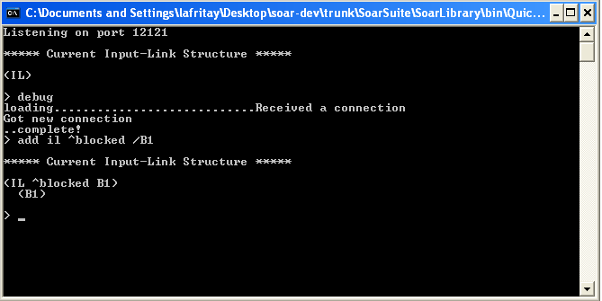
Notice that the ‘/’ sign has been removed before B1, it is only used to indicate that the element is an identifier at the time of creation. In other words, the unique id for blocked is ‘B1’ not ‘/B1’.

Notice that as soon as enter was pressed the input-link structure was updated and re-printed. But for what reason did you add an identifier with an attribute path of blocked to the input-link? The answer is that since we are trying to imitate the game TankSoar, we have to put the same commands on the input-link that TankSoar would. “blocked” is an identifier that has four directions (forward, backward, left and right) that is used to tell the tank which spaces around it are blocked and unblocked.

The entire input and output-link structures have been included on the next page for reference. This is a map of all of the possible structures that could exist on either of these links, note that they do not all have to exist for the program to function. I would suggest printing the next page so that you can reference it as the tutorial progresses.

Map of Input-link and Output-link

^io
^input-link
^blocked
^backward yes/no
^forward yes/no
^left yes/no
^right yes/no
^incoming
^backward yes/no
^forward yes/no
^left yes/no
^right yes/no
^radar
^energy
^distance 0-13
^position left/center/right
^health
^distance 0-13
^position left/center/right
^missiles
^distance 0-13
^position left/center/right
^obstacle
^distance 0-13
^position left/center/right
^open
^distance 0-13
^position left/center/right
^tank
^distance 0-13
^position left/center/right
^io
^input-link
^color red/blue/purple/…
^rwaves
^backward yes/no
^forward yes/no
^left yes/no
^right yes/no
^smell
^color none/red/blue/purple/…
^distance none/0-28
^sound silent/left/right/
forward/backward
^clock 1-N
^direction north/east/south/west
^energy 0-1000
^energyrecharger no/yes
^health 0-1000
^healthrecharger no/yes
^missiles 0-N
^my-color blue/red/purple/…
^radar-distances 1-14
^radar-setting 1-14
^radar-status on/off
^random 0.0-1.0
^resurrected no/yes.
^shield-status on/off
^x 1-14
^y 1-14

^io
^output-link
^move.direction left/right/forward/backward
^rotate.direction left/right
^fire.weapon missile
^radar.switch on/off
^radar-power.setting 1-14
^shields.switch on/off

3.2 Adding Elements With Values
The syntax for adding an element with a value is very similar to adding an identifier. The only difference between the two is that the last argument is not preceded by a ‘/’ symbol. Look at this example:
Creates an identifier on the input-link with the unique id B1
add il ^blocked /B1

Creates a string on the input-link with a value “B1”
add il ^blocked B1

This is the most important lesson to learn about adding structures to the input-link: To create identifiers, always include a ‘/’ sign before the last argument and to create value-based structures (strings, integers and floats) just simply type the value. (Note: the names used as unique id’s given to identifiers are completely arbitrary, although it is a Soar convention to use a capital letter followed by a number, for example, ‘B1’).

If you look at your map of the input and out-link structures from TankSoar, you will see that under the identifier “blocked” there are four elements (backward, forward, left and right). Each of these elements has the possible values of either “yes” or “no.” Let’s add these elements to the input-link. The syntax for adding the element with the attribute path “backward” would be:
This time the shortcut for add which is “a” is used
The value we want this element to have. Represents that there is an open space behind the tank. Note that string values like this are case-sensitive.
a B1 ^backward no
Since we want backward to be located under blocked, we set the parent identifier as B1
The attribute path, just as before

Type the above command into QuickLink and press enter, you should see “^backward no” added to B1. Add the following commands to represent the rest of the blocked structure:

Notice here that we used “b1” instead of “B1”. Remember that identifier names are case-insensitive, so either can be used.
a b1 ^forward yes

a B1 ^left no

a b1 ^right no
After entering in these commands, your screen should look as follows:

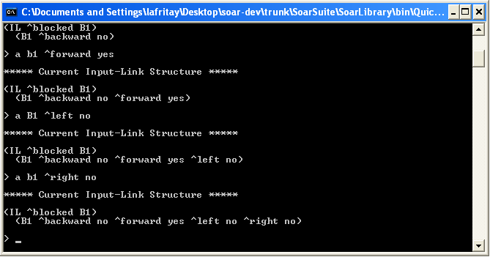
All of the directions have been added to the identifier B1.

The current input-link structure now represents a tank that has a barrier of some sort in front of it, but has open spaces to both its sides and behind it.

4 Running Soar

With the structures we have added to the input-link we have supplied the mapping-bot productions loaded in the Soar Debugger with enough information to take an action. QuickLink has two different ways control can be handed over to Soar.

4.1 Running Until Output
The recommended way of running Soar once the input-link structure has been created is to tell the Agent to run until it produces output. This can be done by typing go or g in the command line. The debugger runs just as if it were hooked up to the actual TankSoar application. After the Soar Agent has processed the information on the input-link, it responds by placing commands on the output-link. These commands are then displayed in the command window in the same format as the input-link structure.

4.2 Run a Cycle
This command allows you to run Soar for a specific amount of cycles. The syntax for doing this would be runcycle <num> or rc <num> where <num> is an integer between 1 and 15 that represents the amount of cycles to be run. For now let’s leave this command for more advanced users.
______________________________________________________________
Type go into the command line and press enter. Your display should look as follows:

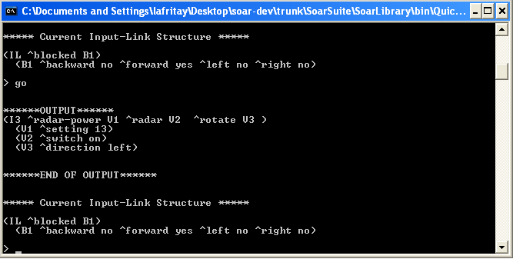
Indicates start of the output phase
Output-link structure created by Soar Agent

You should also notice that the Main Trace window in the Debugger has changed to reflect what has just happened.

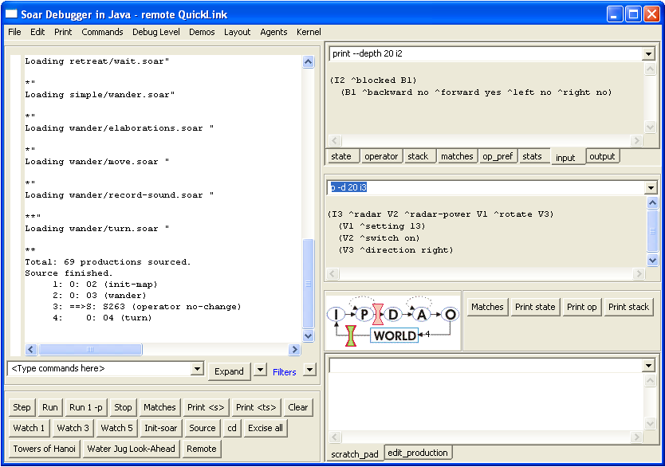
The trace of what is happening on the Soar side of things.
This is what Soar sees on the input-link.
This is what Soar puts on the output-link

If you look at the map of the input and output-link structures you will see that this output looks similar to the map of the output. This output structure is giving the following commands:

- Set the radar-power to 13.
- Turn the radar on.
- Rotate left.

Now the beauty of QuickLink is that you do no have to obey these commands if you do not want to. You can make any changes to the input-link that you see fit. The problem though is that you have to make these changes yourself, they are not done automatically. For the purpose of this tutorial, let’s do our best to follow the output commands.

Note: As you continue to use QuickLink you may notice that the output it displays is different from the output displayed in the debugger. This is because QuickLink only displays the things that have changed on the output-link since the last time it was displayed. This prevents the confusion of trying to determine if an output-link command is new or is leftover from earlier.

5 Making Changes

Now let’s change the input-link to reflect what has been put on the output-link. The first command was to set radar-power to 13. If you look on your TankSoar map of the input-link in right-hand column towards the bottom you will see a structure off of the input-link titled radar-setting which is followed by an int from 1-14. Directly below that is an element called radar-status which corresponds to the second output-link command. Add the following commands one at a time so that we can make these elements active on the input-link:

a il ^radar-setting 13

a il ^radar-status on

You should see these two structures appear on the input-link. Now is a great time to show how specific instances can be tested. If you look once again at the input-link map, you will see that the entire bottom of the left side is dedicated to perceiving other objects using the radar identifier (which fits in with this example because we just turned radar on). Let’s give the tank some input on the objects around it to see how it reacts.

First, we have to create the radar identifier which is found on the input-link:

a il ^radar /R1
Next, let’s tell the tank that there is an enemy tank four spaces in front of it and off to the left. This can be done using the following commands:
Creates a tank identifier off of the radar identifier
a R1 ^tank /T1

a T1 ^distance 4
Puts information about location of the tank on tank identifier
a T1 ^position left

Be sure to notice that we are following the structure of the input-link map. You screen should now look like this:

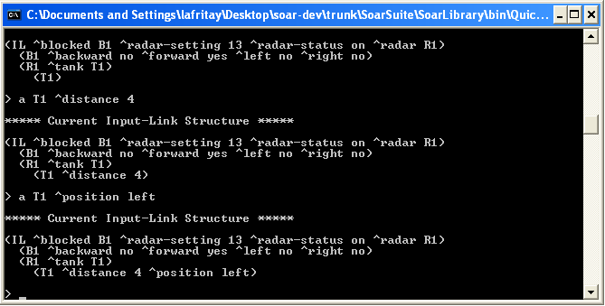

5.1 Retrieving Last Output
Now we have taken care of two of the proposed commands from the output-link, but remember that there were three. What I don’t remember is what that command was. Now to make things worse I can’t see the output-link print anymore. What should I do? Luckily, QuickLink saves what was printed to the output-link so that you can view it again at any time. This is done by typing “LastOutput” or its shortcut “LO” (neither of which is case-sensitive). Do this now to see what command we were forgetting. When the output prints again you will see that we have been ordered to rotate left.
5.2 Altering Elements on Input-Link
The tank has requested that we rotate it left. In order to do this we need to alter the forward element on the blocked identifier to say no and the right element on the blocked identifier to say yes, this is equal to a rotate left. Changing a pre-existing element has its own syntax in QuickLink which is as follows:

change <parent-id> ^<path> <old value> <new value>

You can either use change or ‘c’.
Variable for parent id. Carrot symbols represent variables.
Variable for path. Carrot symbols represent variables.
Variables for old value and new value. Carrot symbols represent variables.

Enter the following commands to change the forward and right elements which are located on blocked:

change B1 ^forward yes no

c b1 ^right no yes

Your screen should look as follows:

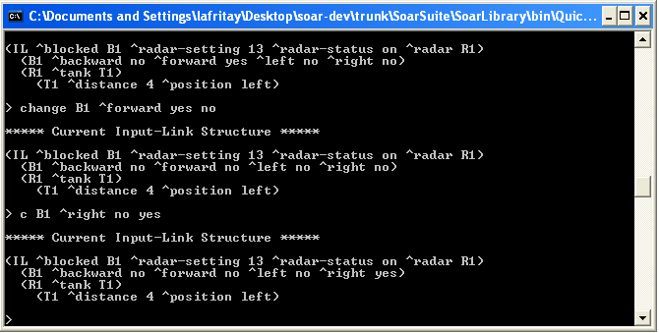

5.3 Saving and Loading A Structure
Adding and modifying all of those elements was a lot of work. QuickLink allows you to save and load the current input-link structure so that you are not risking losing all of your work and so that you can load them later to save time. Let’s practice this.

Type save practice.txt and press enter. This saves your current input-link structure to the file practice.txt in <soar-dir>\SoarSuite\Tools\QuickLink\. You will be notified of this and press any key when you are ready.

Now type clear to erase everything currently on the input-link.

Now type load practice.txt to reload your input-link structure. (Note:
Doing a save, followed by a clear, followed by a load will actually blink the input-link structure. This means that on the Soar side of things, these are actually all new elements, which will cause rules to retract and fire again.) Your structure should be just as you left it and the trace should look like this:

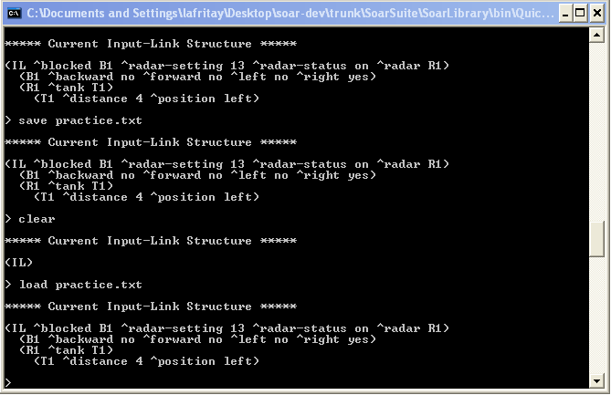
5.4 More Running
Now let’s see what happens. Type go just as before and press enter. Your screen should look like this:

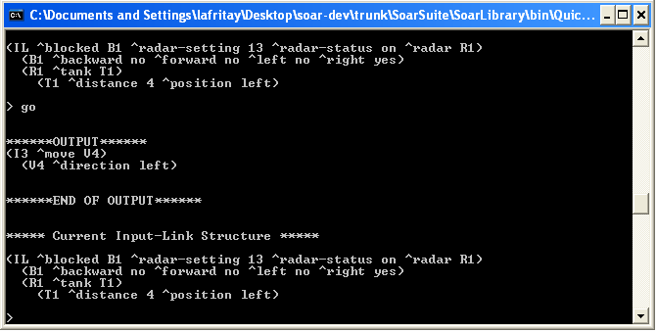
Command indicating that the tank wants to move to the left.

The Soar Agent has instructed the tank to move left via the output-link. It is now time to make some more changes. Think about why this has happened. We have simulated the TankSoar environment to make our tank think that there is an enemy tank 4 spaces ahead of him and one space to the left. The tank is ordering us to move left so that it will be able to shoot the enemy tank. In order to move the tank left here is what needs to be changed:

- The tank is no longer blocked on the right.
- The enemy tank now has a position of center.
- We should give the tank missiles so it can shoot the other tank.

Let’s make these changes to see how the tank responds.
5.5 Deleting
While it makes sense to use the change command to alter the values needed to move the tank left, we are going to delete them and make new ones so that you can learn how to delete. The delete command is very similar to add command:
Warning: Do not enter these next two delete commands; they are only shown for comparison to the add commands.

Deletes identifier B1 with path blocked to the input-link.

Adds identifier B1 with path blocked to the input-link.
add il ^blocked /B1

delete il ^blocked /B1

The only difference between add and delete is the first word

Adds value yes with path right to the identifier B1.
Deletes value yes with path right to the identifier B1.
add B1 ^right yes

delete B1 ^right yes

Let’s try this, first delete ^right yes off of blocked and ^position left off of tank with the following commands:

delete B1 ^right yes
“d” is the shortcut for “delete”.

d T1 ^position left

Now add in new elements with the following commands:
Adds ^right no to blocked identifier.
Adds ^position center to blocked identifier.
a B1 ^right no

a t1 ^position center

Note: We could have used the change command to get the same effect here, but using fewer steps. I wanted to use the delete command to demonstrate how it worked.

If you look at your TankSoar input-link map, you will see that about halfway down the right column there is an attribute named missiles which is followed by an integer. Let’s add this to our input-link structure:

a il ^missiles 15

Your input-link structure should now look like:

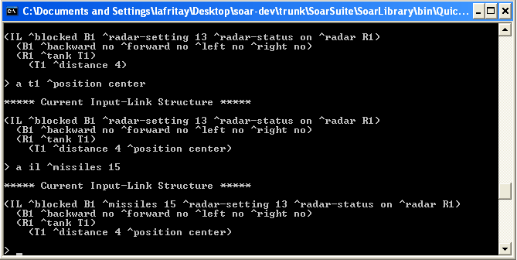

Now type go to see how the Agent responds. You should see the following in the command window:

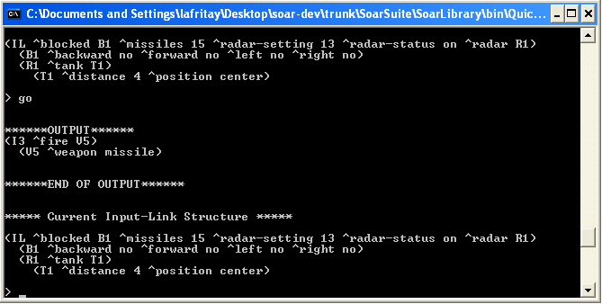
The Agent orders a missile to be fired.

And if you look in the Debugger’s Main Trace window:

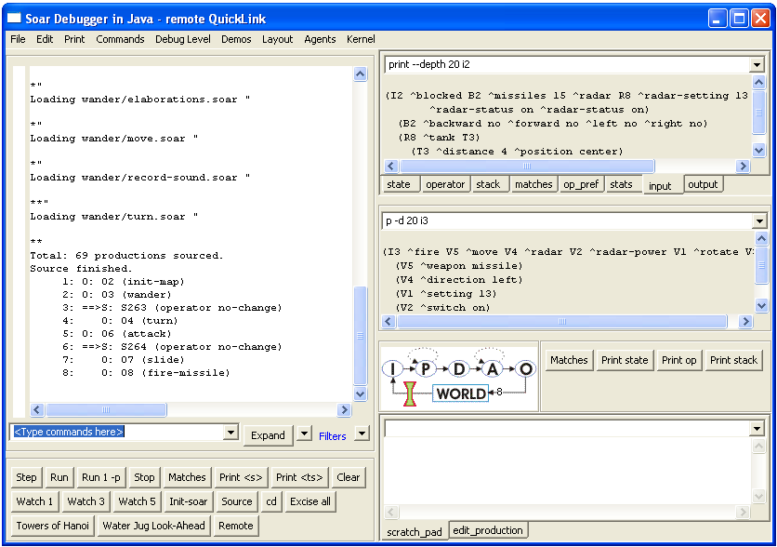
The Agent orders a missile to be fired.
6 Scripts

Now that you know the basic commands on how to add/delete/change structures on the input-link, it is time to learn about QL’s most powerful aspect, that being the ability to run scripts. Since the main purpose of this program is to allow for quick and deliberate debugging, it would be nice if you didn’t have to go through the steps of re-creating a whole set of input-link structures every time you wanted to debug code. This would be not only slow, but also very error prone. To combat this, QL creates scripts as you type in commands. For instance, all of the commands you have typed, from debug to the last time you typed go is sitting in QL’s memory. All you have to do it save it to a file so that it can be run again.

6.1 Saving Scripts
The syntax for saving a script of commands is:

script <filename.txt> or sc <filename.txt>

Let’s save the 4 steps we just did as a script. To do this, type

script tanksoarQL.txt

All scripts are saved in SoarLibrary/bin

6.2 Running Scripts
We just spent all this time creating and saving a script, so we might as well run it again. To do this, we first need to reset a few things. At any time, you can access the Debugger’s command line directly through the QL command-line Let us use this to initialize the Soar Agent so it is ready to start running again. In the command window, type:

init

You should see a message notifying you that the Agent was reinitialized. Reinitializing an agent (as we just did) does not clear the input-link. To clear the input-link you must explicitly use the clear keyword as we did before. To clear the input link, type:

clear

Now it is time to load in the script that we just saved. To do this, type:

load tanksoarQL.txt or l tanksoarQL.txt

When you press enter your script will run and the TankSoar agent should repeat the behavior that it just went through.

6.3 Pause and Continue

Let’s say you want to run a script that you have saved, but want it to run slower, or you want to make some change to the input link at an arbitrary point. In order to accomplish this, you can put various pause statements throughout your script. Open up the tanksoarQL.txt script we just made, it should look like this:

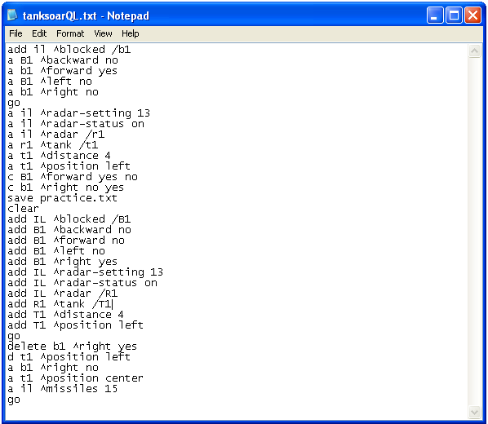
Remember the first command we used was ‘debug’. This command is not saved in a script by default, but can be manually added if you want it.
Notice that the save call is part of the script. Practice .txt will be recreated each time this is run.
Notice that the load practice.txt call is not included in the script. Instead, its effects (the next 11 lines) are included. This helps to create fewer dependencies between files.

Now let’s say that you want to examine each of the input-link structures before they are run. To do this we are going to add Pause statements before each of the calls to go. Do this and your file should look like:

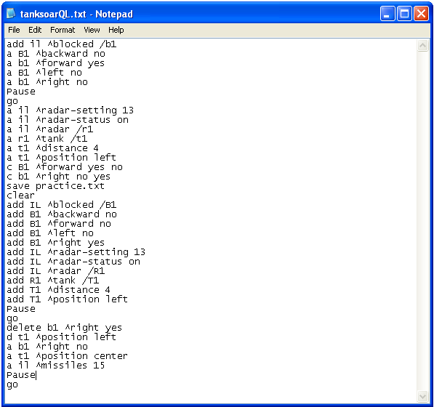

DO NOT FORGET TO SAVE YOUR CHANGES TO THE FILE! After you saved the file, go back to the QL screen, type init and then clear just as before. Now type load tanksoarQL.txt your screen should look as follows:

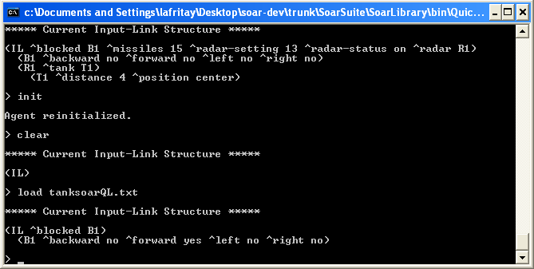
The script is now paused directly before the first call to ‘go’. At this point you could change the input-link anyway you see fit.

To continue running the script, type continue or just cont. You should see the script advance to right before the next call to ‘go’. Notice also that the SoarJavaDebugger screen is also updating with the script. Type cont twice more to finish running the script.

6.4 Using clears

QL automatically begins storing input-link structures that are run from the time it is launched in case you want to save them a s a script. At any time, this memory can be cleared by typing clears.

Using clears correctly is the key to manipulating scripts. For example, how would you add a new input-link structure to the beginning of tanksoarQL.txt? The proper way to do this would be to type clears, enter the new input-link structure and type go, then run through the whole script stored in tanksoarQL.txt. Now typing script <newfile.txt> will save tanksoarQL.txt with a new input-link structure before it. Similarly, if you wanted to save the last portion of a certain script, you would run the script until reaching the structure you wanted to start at (using Pause), type clears, then after executing the last structure that is to be included in the script, you would type script.

7 Table of Commands

Name | Shortcut | Arguments/Examples | function
quit or exit | -- | --  quit or exit | Exits the program
clear | -- | --  clear | Clears current input-link structure, has no effect on script memory.
save | s | <filename.txt>  save structure.txt | Saves the current input-link structure to filename.txt.
load | l | <filename.txt>  load structure.txt | Loads filename.txt whether it is a script or just a single structure
add | a | <parent id> ^<path> /<my id>  add il ^blocked /B1 | Adds an identifier to <parent id> with path <path> and id <my id>. Must have ‘/’ sign. il is the default id for the input-link.
add | a | <parent id> ^<path> <value>  add B1 ^forward yes | Adds a string, int or float to <parent id> with path <path> and value <value>.
change | c | <parent id> ^<path> <old value> <new value>  change B1 ^forward yes no | Changes element with <parent id> and path <path> from <old value> to <new value>. <old value> and <new value> must be of same type.
delete | d | <parent id> ^<path> /<my id>  delete il ^blocked /B1 | Deletes an identifier from <parent id> with path <path> and id <my id>. Must have ‘/’ sign.
delete | d | <parent id> ^<path> <value>  delete B1 ^forward no | Deletes a string, int or float from <parent id> with path <path> and value <value>.
clears | cs | --  clears | Clears out all input-link structures currently stored in script memory
script | sc | <filename.txt>  script filename.txt | Saves all input-link structures stored in script memory as a script in filename.txt.
ends | es | --  ends | Only used while running a script loaded from a file, ends the running of the script.
go | g | --  go | Runs Soar until output is generated by the Agent.
runcycle | rc | <num cycles>  runcycle 4 | Runs Soar for a specific number of cycles <num cycles>
lastoutput | lo | --  lastoutput | Re-prints the last output structure
status | -- | --  status | Re-prints the last input structure
debug | -- | --  debug | Spawns the SoarJavaDebugger and creates a remote connection to it.
remote | -- | --  remote | Forces QuinkLink to destroy its internal instance of the Soar Kernel and attempts to remotely connect it to another instance.
local | -- | -- | QuickLink will create a new instance of the Soar Kernel internally

